Google Classroom

**Online Learning Platform**

Use-Case-Realization Specification: Join Class

Version 1.1

Revision History

| **Date** | **Version** | **Description** | **Author** |
| --- | --- | --- | --- |
| 05/12/2021 | 1.0 | Initial version | Nguyen Nhu Hong Phuc |
| 09/12/2021 | 1.1 | Fixed version | Nguyen Nhu Hong Phuc |
|  |  |  |  |
|  |  |  |  |

Table of Contents

1. Introduction 2

1.1 Purpose 2

1.2 Scope 2

1.3 Definitions, Acronyms, and Abbreviations 2

1.4 References 2

1.5 Overview 2

2. Flow of Events—Design 2

3. Derived Requirements 2

Use-Case-Realization Specification: Create Post

# Introduction

## Purpose

This Use-case Realization Specification provides an overview of how the corresponding use-case is realized to the design model in terms of collaborating objects.

## Scope

This document only applies to the Use-case: Join Class

## Definitions, Acronyms, and Abbreviations

None

## References

## Overview

In part 2, the use-case realization will be further illustrated by using class diagrams and sequence diagrams. Later on, from the realized diagrams, other requirements that have not been considered in the design model will be listed in section 3 – Derived Requirements.

# Flow of Events—Design

There are four types of object this use-case realization. They include: Student View, Join Controller, Join Model which is a data access class. The sequence in which the operations are invoked is realized according to Model-View-Controller architecture.

## sequence diagram

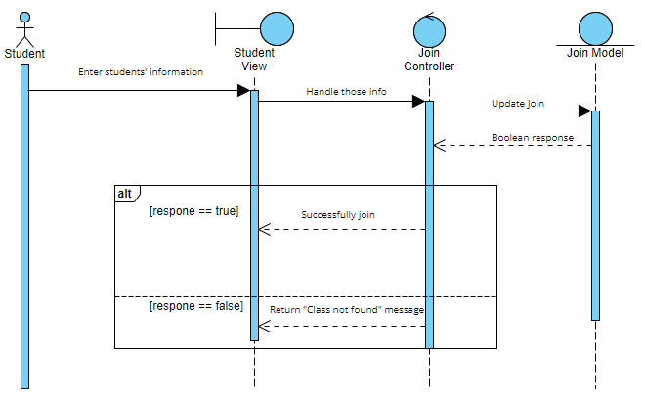

## class diagram

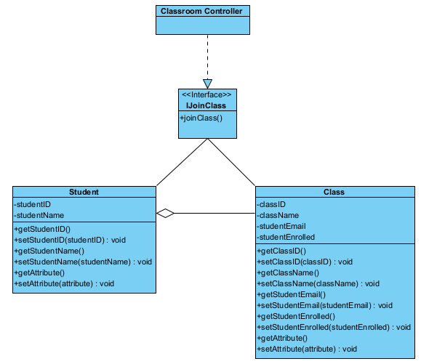

# Derived Requirements

After joining the class , the students can access many material in the classroom and create post easily